PROJECT PREPARATION DOCUMENT
Power BI Dashboard
Loan Collection & Agent Performance Analysis

Analyst : Rajeev Kumar | Tool : Power BI Desktop
Domain : BFSI | Pages : 3 | Visuals : 20+ | DAX Measures : 9

SECTION 1 — PROJECT OVERVIEW

1.1 Objective
After completing Python EDA, SQL Analysis, and Excel MIS Dashboard, we built a 3-page interactive Power BI Dashboard for the Loan Collection & Agent Performance project. The dashboard allows management to explore data dynamically using slicers and filters — giving real-time business insights.

1.2 Dashboard Structure
Page | Name | Content
Page 1 | Overview | 6 KPI Cards, Region Chart, Monthly Trend, Collection Status, Loan Type, DPD Chart, Month & Loan Type Slicers
Page 2 | Agent Performance | 3 KPI Cards, Agent Collection Bar, Collection Rate Chart, Team Leader Chart, Region Slicer
Page 3 | Risk Analysis | 3 KPI Cards, DPD Bucket Chart, Loan Type Chart, Collection Status Donut, At Risk Trend, DPD Slicer

1.3 DAX Measures Created
Measure | Formula / Purpose
Total Collection | SUM(EMI_Collected_Amount) — Total EMI collected
Total EMI Due | SUM(EMI_Due_Amount) — Total EMI due
Collection Rate % | DIVIDE(Collected, Due, 0) * 100 — Collection efficiency
Total Agents | DISTINCTCOUNT(Agent_Name) — Unique agents count
Total Records | COUNTROWS(Raw_Data) — Total records
Total At Risk EMI | CALCULATE(SUM(Due), DPD <> X Current) — At risk amount
Top Agent Collection | MAXX(SUMMARIZE(...), Agent_Total) — Best agent amount
Bottom Agent Collection | MINX(SUMMARIZE(...), Agent_Total) — Lowest agent amount
Avg Agent Collection | AVERAGEX(SUMMARIZE(...), Agent_Total) — Average per agent

1.4 Key DAX Concepts Used
Concept | Explanation
SUM, DIVIDE, COUNTROWS | Basic aggregation functions
DISTINCTCOUNT | Count unique values — used for Total Agents
CALCULATE | Apply filter to calculation — used for At Risk EMI
SUMMARIZE | Group data like SQL GROUP BY — temporary table
MAXX / MINX / AVERAGEX | Row by row calculation on grouped table
Filter Context | Power BI automatically filters measure by visual context — same measure gives different result in chart vs card

SECTION 2 — PAGE 1 : OVERVIEW DASHBOARD

Page 1 is the main overview dashboard. It gives management a complete picture of loan collection performance across all regions, months, loan types, and DPD buckets in a single view.

2.1 Dashboard Screenshot — Page 1
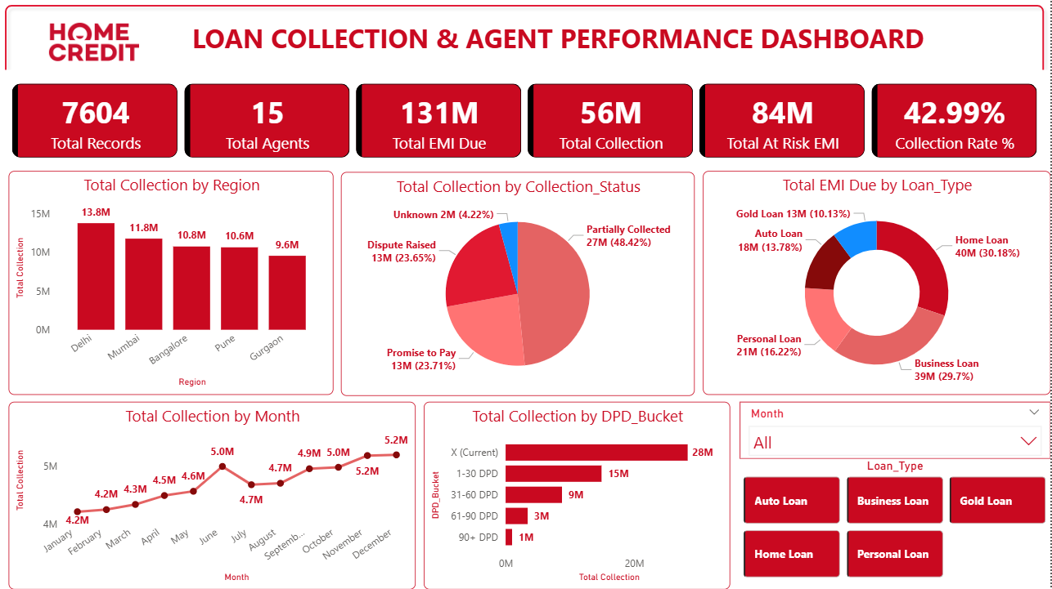

2.2 Visuals on Page 1
Visual | Details
6 KPI Cards | Total Records (7,604), Total Agents (15), Total EMI Due (131M), Total Collection (56M), Total At Risk EMI (84M), Collection Rate % (42.99%)
Region Bar Chart | Total Collection by Region — Delhi highest 13.8M, Gurgaon lowest 9.6M
Collection Status Pie | Partially Collected 48.42%, Dispute Raised 23.65%, Promise to Pay 23.71%, Unknown 4.22%
Loan Type Donut | EMI Due by Loan Type — Home Loan highest 30.18%, Gold Loan lowest 10.13%
Monthly Trend Line | Collection Jan to Dec — upward trend from 4.2M to 5.2M
DPD Bucket Bar | X Current highest 28M, 90+ DPD lowest 1M
Month Slicer | Dropdown — filter all visuals by month
Loan Type Slicer | Tile style — filter all visuals by loan type

2.3 Key Insights — Page 1
Business Insights
- Total Collection is 56M (5.64 Crore) for full year 2024 — healthy yearly performance
- Collection Rate is only 42.99% — 57% EMI still uncollected — urgent improvement needed
- Total At Risk EMI is 84M (8.4 Crore) — 64% of total EMI is at risk
- Delhi is top region — 13.8M — Gurgaon is lowest — 9.6M — 4.2M gap
- Partially Collected is 48.42% — highest status — follow up can convert to full collection
- Monthly trend shows upward growth — Jan 4.2M to Dec 5.2M — 23% annual improvement
- X Current DPD has 28M — good sign — most customers paying on time
- 90+ DPD only 1M — but very difficult to recover — urgent legal action needed

2.4 Business Impact — Page 1
Business Impact
- Management can see complete performance overview in one page — saves time
- Month slicer allows month wise analysis — identify best and worst months instantly
- Loan Type slicer helps product team analyze which loan needs strategy change
- KPI cards give instant health check of collection performance
- 57% uncollected EMI is a critical alert — management can take immediate action

SECTION 3 — PAGE 2 : AGENT PERFORMANCE DASHBOARD

Page 2 focuses entirely on agent and team leader performance. It helps management identify top performers, bottom performers, and team level gaps — enabling data driven HR and training decisions.

3.1 Dashboard Screenshot — Page 2
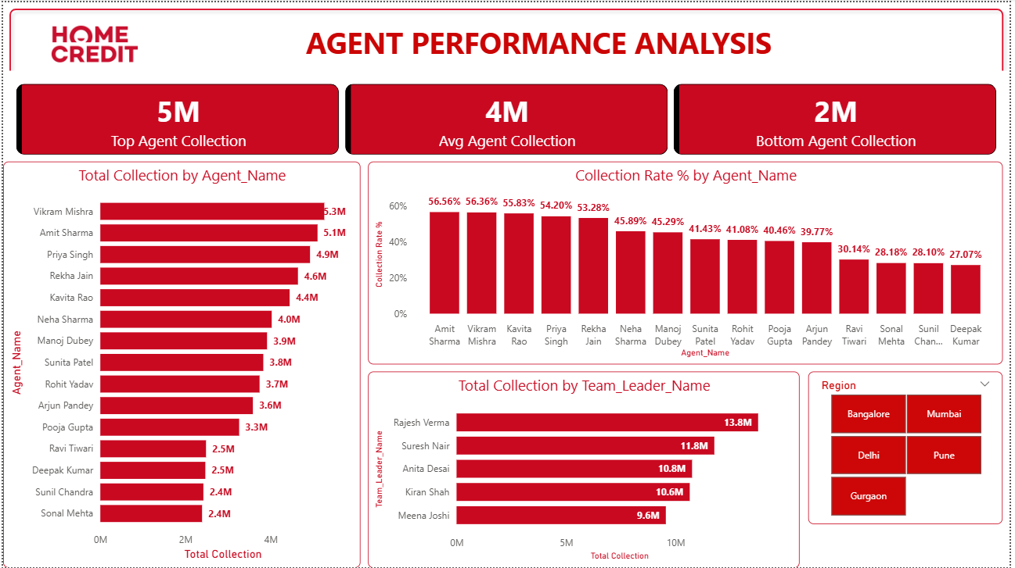

3.2 Visuals on Page 2
Visual | Details
Top Agent KPI Card | Highest collection by any single agent — 5M (Vikram Mishra 52.6L)
Avg Agent KPI Card | Average collection per agent — 4M (37.7L average)
Bottom Agent KPI Card | Lowest collection by any agent — 2M (Sonal Mehta 23.9L)
Agent Collection Bar Chart | All 15 agents ranked by total collection — Vikram Mishra top, Sonal Mehta bottom
Collection Rate % Chart | All 15 agents collection rate — Amit Sharma highest 56.56%, Deepak Kumar lowest 27.07%
Team Leader Bar Chart | 5 TLs compared — Rajesh Verma best 13.8M, Meena Joshi lowest 9.6M
Region Slicer | Tile style — filter all visuals by region

3.3 Key Insights — Page 2
Business Insights
- Vikram Mishra is top agent by collection amount — 5.3M (52.6L)
- Amit Sharma has highest collection rate — 56.56% — most efficient agent
- Sonal Mehta is bottom agent — only 2.4M (23.9L) — needs urgent coaching
- Gap between top and bottom agent — 28.7L — 54% difference — very large gap
- Rajesh Verma is best Team Leader — 13.8M — Delhi team is strongest
- Meena Joshi team lowest — 9.6M — Gurgaon team needs strategy review
- Collection Rate chart shows 3 clear tiers — Elite 55%+, Average 40-45%, Needs Improvement below 30%
- Region slicer helps TL analyze their own team performance instantly

3.4 Business Impact — Page 2
Business Impact
- HR team can identify agents who need training — bottom 4 agents below 30% rate
- Management can replicate top agent strategies across the team
- Region slicer allows regional manager to focus on their own team
- Team Leader comparison helps senior management evaluate TL effectiveness
- If bottom agents improve to average rate — estimated 15-20L additional collection possible
- Avg Agent KPI helps set realistic targets — current avg 37.7L per agent

SECTION 4 — PAGE 3 : RISK ANALYSIS DASHBOARD

Page 3 is the risk analysis dashboard. It helps the risk and collections team identify at-risk accounts, understand DPD bucket distribution, and track monthly risk trends — enabling proactive risk management.

4.1 Dashboard Screenshot — Page 3
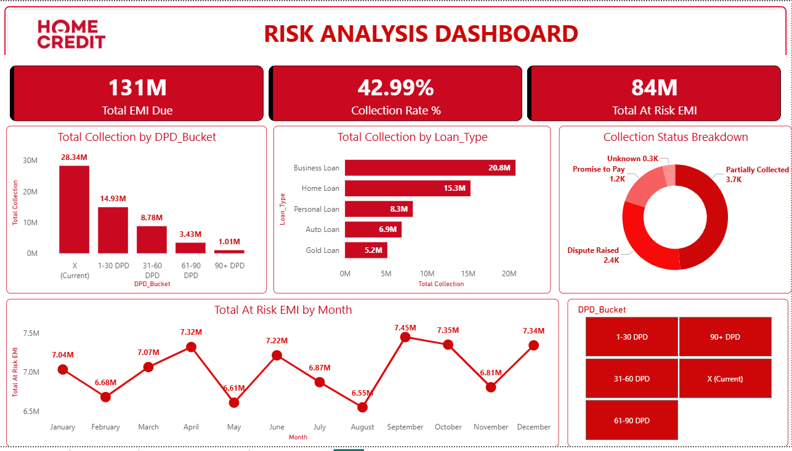

4.2 Visuals on Page 3
Visual | Details
Total EMI Due KPI | 131M (13.1 Crore) — total EMI due across all buckets
Collection Rate % KPI | 42.99% — overall collection efficiency
Total At Risk EMI KPI | 84M (8.4 Crore) — EMI in 1-30, 31-60, 61-90, 90+ DPD buckets
DPD Bucket Column Chart | X Current 28.34M highest, 90+ DPD 1.01M lowest — risk distribution
Loan Type Bar Chart | Business Loan highest collection 20.8M, Gold Loan lowest 5.2M
Collection Status Donut | Partially Collected 3.7K records, Dispute Raised 2.4K, Promise to Pay 1.2K
At Risk EMI Monthly Trend | Monthly at risk EMI trend — shows seasonal risk patterns Jan to Dec
DPD Slicer | Tile style — filter all visuals by DPD bucket

4.3 Key Insights — Page 3
Business Insights
- Total At Risk EMI is 84M (8.4 Crore) — 64% of total EMI 131M is at risk
- X Current bucket 28.34M — good sign — most EMI being paid on time
- 1-30 DPD has 14.93M — immediate follow up needed — still highly recoverable
- 90+ DPD only 1.01M — but recovery rate is only 9.24% — practically write-off risk
- Business Loan highest collection 20.8M — business customers most financially disciplined
- Gold Loan lowest collection 5.2M — secured loan but still low recovery — review needed
- Monthly at risk trend shows seasonal pattern — May and August dips visible
- Partially Collected 3.7K records — largest group — targeted follow up can recover significant amount

4.4 Business Impact — Page 3
Business Impact
- Risk team can identify which DPD bucket needs immediate attention
- DPD slicer allows bucket wise deep dive — X Current vs 90+ DPD analysis
- Monthly at risk trend helps predict future risk and plan collection drives
- Loan type analysis helps product team design product specific recovery strategies
- 84M at risk is a critical business metric — management can set recovery targets
- Collection Status donut shows Promise to Pay 1.2K — these should be prioritized for follow up

SECTION 5 — COMPLETE PROJECT SUMMARY

5.1 All Pages Summary
Page | Key Finding | Business Action
Page 1 — Overview | Collection Rate only 42.99% — 57% uncollected | Urgent collection strategy review needed
Page 1 — Overview | Delhi 13.8M vs Gurgaon 9.6M — 4.2M gap | Replicate Delhi strategy in Gurgaon
Page 1 — Overview | June spike — 5M collection | Run special campaigns every quarter
Page 2 — Agent | Top vs Bottom gap — 28.7L — 54% difference | Training program for bottom 4 agents
Page 2 — Agent | Rajesh Verma best TL — 13.8M | Study and share his leadership approach
Page 2 — Agent | 3 agents below 30% rate | Urgent performance improvement plan
Page 3 — Risk | 84M at risk — 64% of total EMI | Urgent recovery plan for all DPD buckets
Page 3 — Risk | 1-30 DPD — 14.93M recoverable | Immediate follow up on 1-30 DPD accounts
Page 3 — Risk | Business Loan best — 20.8M collected | Prioritize Business Loan collection

5.2 Dashboard Features
Feature | Benefit
Interactive Slicers | Filter all visuals simultaneously — Month, Loan Type, Region, DPD Bucket
3 Dedicated Pages | Each page focuses on one area — Overview, Agent, Risk
9 DAX Measures | Custom calculations — Collection Rate, At Risk EMI, Top/Bottom Agent
20+ Visuals | Complete story from KPI cards to detailed charts
Home Credit Branding | Professional logo and consistent theme across all pages
Filter Context | Same measure gives different values in different visual contexts automatically

SECTION 6 — INTERVIEW PREPARATION

6.1 How to Present Power BI Dashboard in Interview

Step 1 — Introduction (30 seconds)
- Say: I built a 3-page interactive Power BI dashboard for loan collection analysis
- Say: Page 1 is overview, Page 2 is agent performance, Page 3 is risk analysis
- Say: Dashboard has 9 custom DAX measures and 20+ visuals with interactive slicers

Step 2 — Walk through Page 1 (1 minute)
- Say: Collection Rate is 42.99% — 57% EMI still uncollected — critical finding
- Say: Delhi is top region at 13.8M — Gurgaon lowest at 9.6M — 4.2M gap
- Say: Monthly trend shows upward growth — 23% improvement from Jan to Dec
- Say: Month and Loan Type slicers allow dynamic filtering of all visuals

Step 3 — Walk through Page 2 (1 minute)
- Say: Top agent Vikram Mishra collects 5.3M vs bottom agent Sonal Mehta 2.4M
- Say: Gap is 54% — I used MAXX and MINX DAX functions to calculate these KPIs
- Say: Rajesh Verma is best Team Leader — his Delhi team performs strongest
- Say: Region slicer allows each regional manager to analyze their own team

Step 4 — Walk through Page 3 (1 minute)
- Say: 84M — 64% of total EMI is at risk — most critical finding
- Say: 1-30 DPD has 14.93M — immediate follow up needed — still recoverable
- Say: I used CALCULATE with filter to create the At Risk EMI measure
- Say: DPD slicer allows risk team to drill into specific DPD buckets

6.2 Expected Interview Questions & Answers

Q1. What is DAX and how is it different from Excel formulas?
Answer: DAX stands for Data Analysis Expressions. It is the formula language used in Power BI. Unlike Excel formulas that work on individual cells, DAX works on entire columns and tables. The most important concept in DAX is Filter Context — the same measure gives different results based on what filters are applied by the visual. For example, my Total Collection measure shows 56M overall but shows 13.8M when Delhi is selected in the visual.

Q2. What is Filter Context in Power BI?
Answer: Filter Context is the set of filters applied to a calculation at any point in time. When I place Total Collection in a bar chart with Region on the axis — Power BI automatically applies a region filter for each bar. So Delhi bar shows Delhi collection, Mumbai bar shows Mumbai collection — same measure, different filter context. This is why I did not need to create separate measures for each region.

Q3. What is CALCULATE and when did you use it?
Answer: CALCULATE is the most important DAX function. It evaluates an expression in a modified filter context. I used it for Total At Risk EMI — I wanted to sum EMI Due Amount but only for rows where DPD Bucket is not X Current. The formula is CALCULATE(SUM(EMI_Due_Amount), DPD_Bucket <> X Current). Without CALCULATE I cannot override the natural filter context.

Q4. What is SUMMARIZE and how did you use it with MAXX?
Answer: SUMMARIZE creates a temporary grouped table — similar to SQL GROUP BY. I used it inside MAXX to find the top agent collection. First SUMMARIZE groups data by Agent_Name and calculates each agent's total collection. Then MAXX iterates through this grouped table and returns the maximum value. This gives the single highest collection amount across all agents.

Q5. What is the difference between a Measure and a Calculated Column?
Answer: A Measure is calculated dynamically based on filter context — it has no fixed value until used in a visual. A Calculated Column is calculated row by row when data is loaded — it becomes a permanent column in the table. I used only Measures in this project because all my calculations depend on filter context — region, month, DPD bucket etc. Calculated Columns would have been wrong here because they cannot respond to slicer filters.

Q6. How did you make the dashboard interactive?
Answer: I added four slicers — Month dropdown on Page 1, Loan Type tile slicer on Page 1, Region tile slicer on Page 2, and DPD Bucket tile slicer on Page 3. All slicers are connected to all visuals on their respective pages. When a user selects a filter — all charts, cards and tables update simultaneously. This allows management to drill down without needing any technical knowledge.

Q7. What was the most important insight from your Power BI dashboard?
Answer: The most important insight was from Page 3 — 84M out of total 131M EMI is at risk — that is 64%. This means almost two thirds of the total EMI portfolio is either late or in dispute. This is a critical business risk. The dashboard also shows that 1-30 DPD bucket has 14.93M which is still recoverable — so management should immediately deploy collection resources to this bucket before these accounts move to higher DPD buckets.

Q8. Why did you create 3 separate pages instead of one?
Answer: Different stakeholders need different information. Senior management wants overview — Page 1. HR and Team Leaders want agent performance — Page 2. Risk and Collections team wants DPD and risk analysis — Page 3. Putting everything on one page would make it cluttered and hard to read. Three focused pages make the dashboard more usable and professional.

Q9. How is your Power BI dashboard different from your Excel dashboard?
Answer: Excel dashboard is static — values do not change when you click something. Power BI dashboard is fully interactive — slicers filter all visuals simultaneously. Power BI also handles large data much faster than Excel. DAX measures in Power BI are more powerful than Excel formulas — especially for filter context calculations. Also Power BI can be published online and shared with stakeholders — Excel cannot do this easily.

Q10. What improvements would you make to this dashboard?
Answer: I would add three improvements. First — a tooltip page showing agent details when you hover over a data point. Second — drill through functionality so clicking a region takes you to agent level detail for that region. Third — conditional formatting on KPI cards — green when above target, red when below. I would also connect it to a live database so data updates automatically without manual refresh.

Final Tips for Power BI Interview
- Always open the dashboard and walk through it — do not just describe it verbally
- Use exact numbers — not just 'Delhi is best' but 'Delhi collected 13.8M — highest among 5 regions'
- Explain at least 2-3 DAX measures in detail — CALCULATE and SUMMARIZE are most important
- Mention Filter Context — this separates a real Power BI developer from a beginner
- Connect findings to business actions — not just 'this shows X' but 'management should do Y because of X'
- Mention that you validated Power BI findings against Python EDA and SQL — shows cross tool thinking

